**Equipment Operational Data**

1. Abstract
2. Existing system
3. Current system
4. How to use
   1. Process
      1. Block diagram
5. How is it made
   1. Hardware and Software
   2. Forms
   3. Datalists
   4. Userviews
6. 3 users
7. Access limits for each user

**Screenshots and Explanation**

Admin User

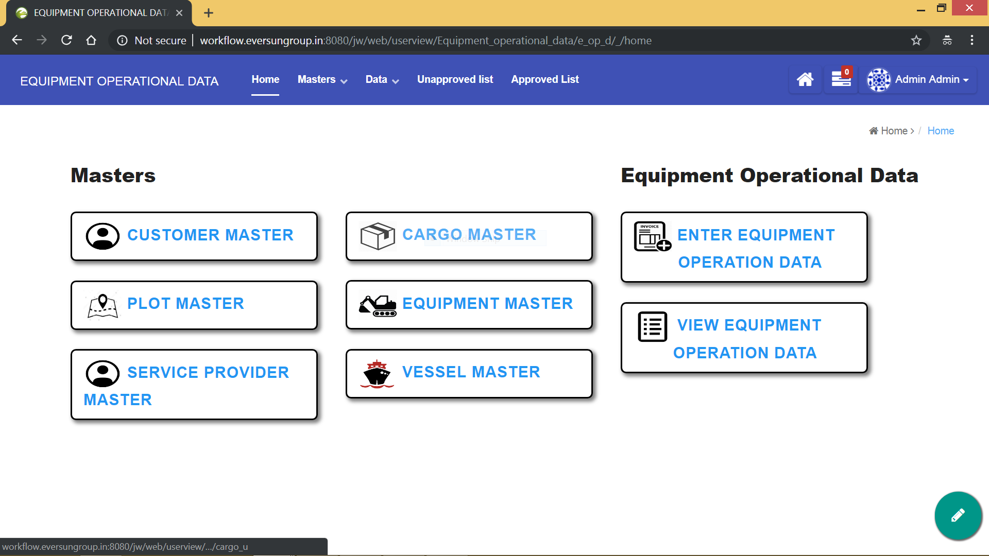

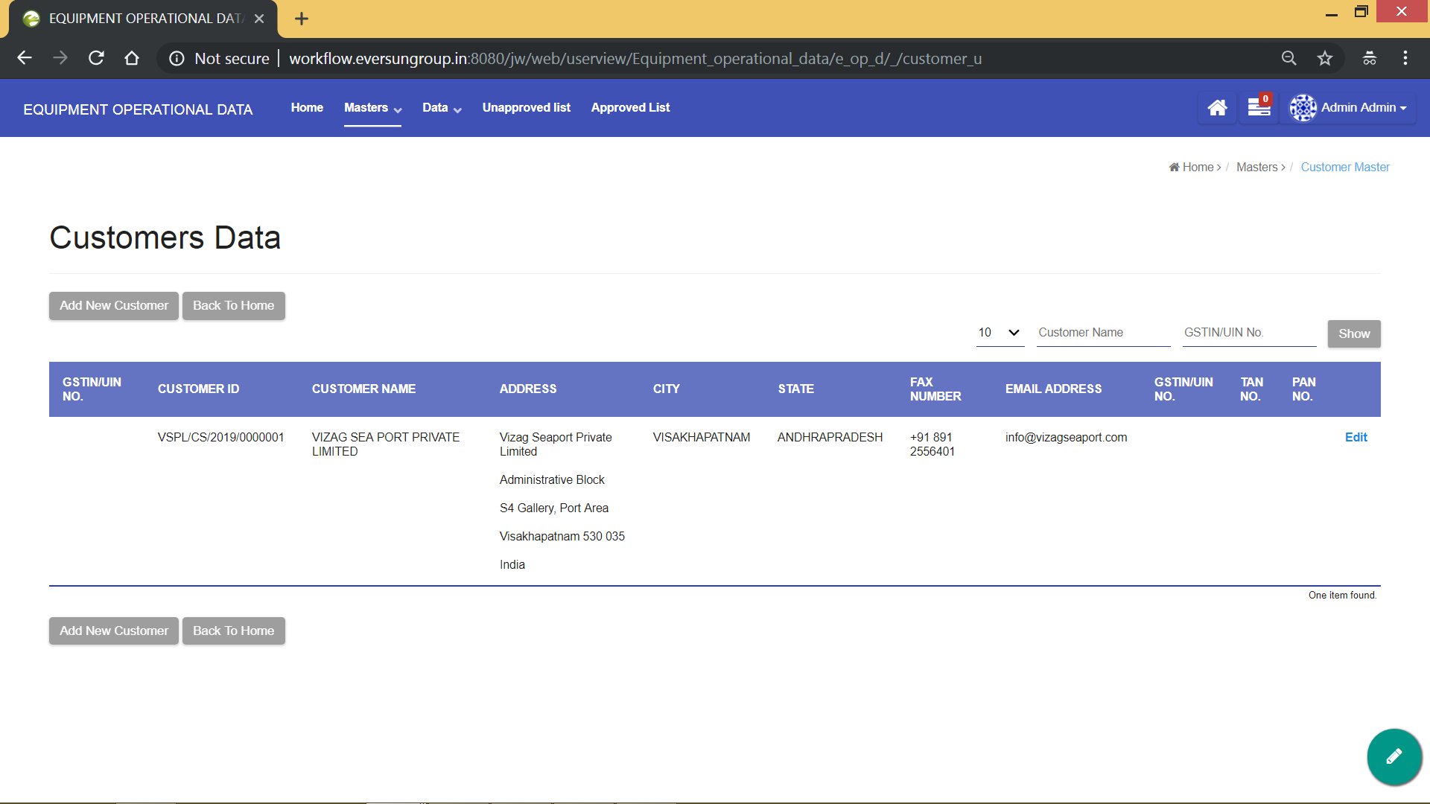

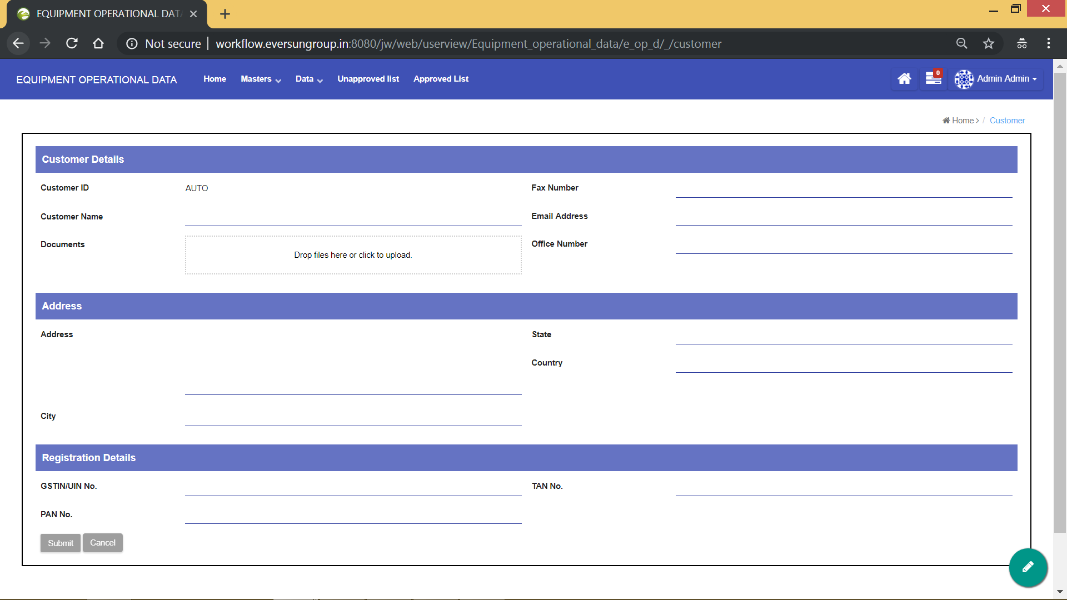

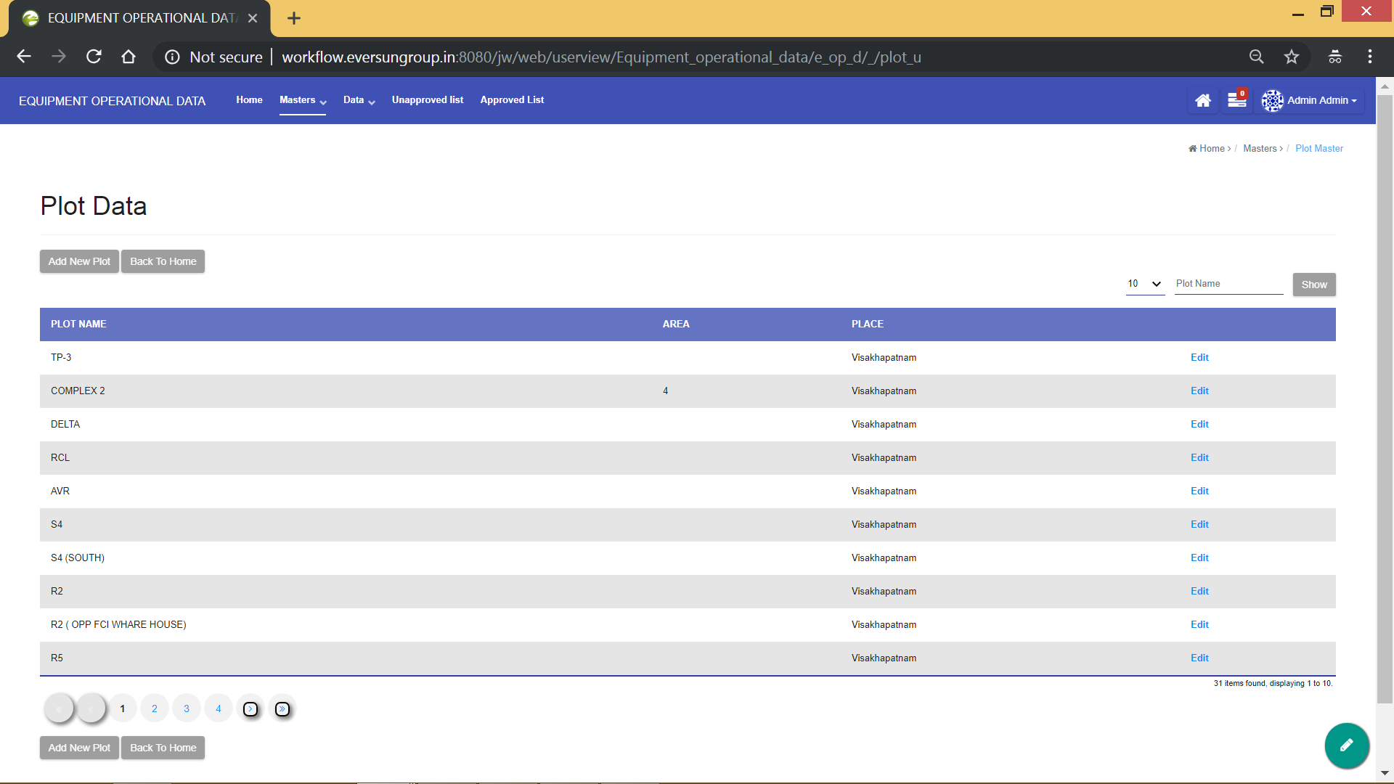

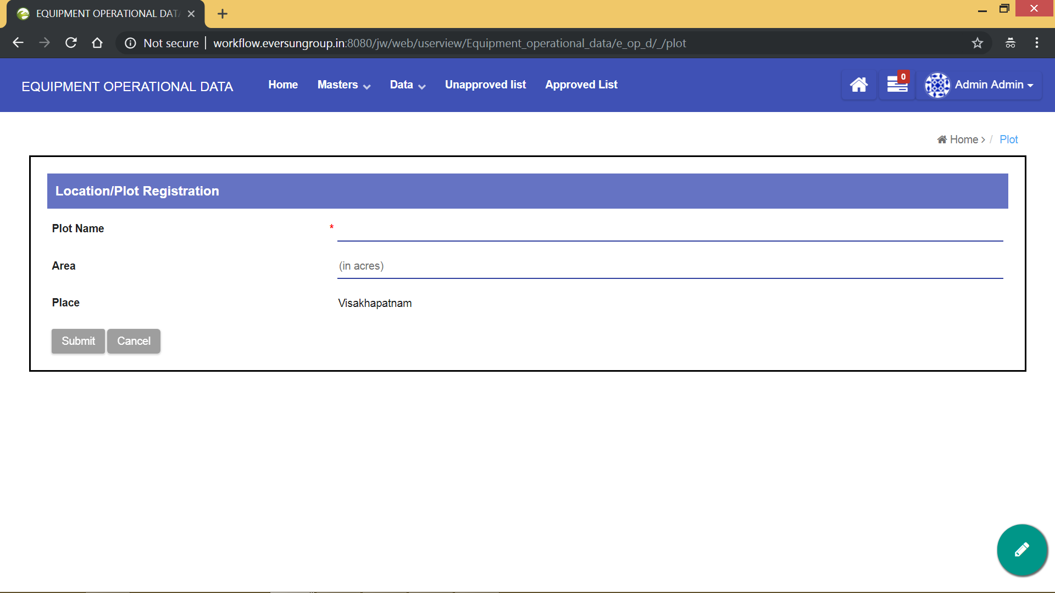

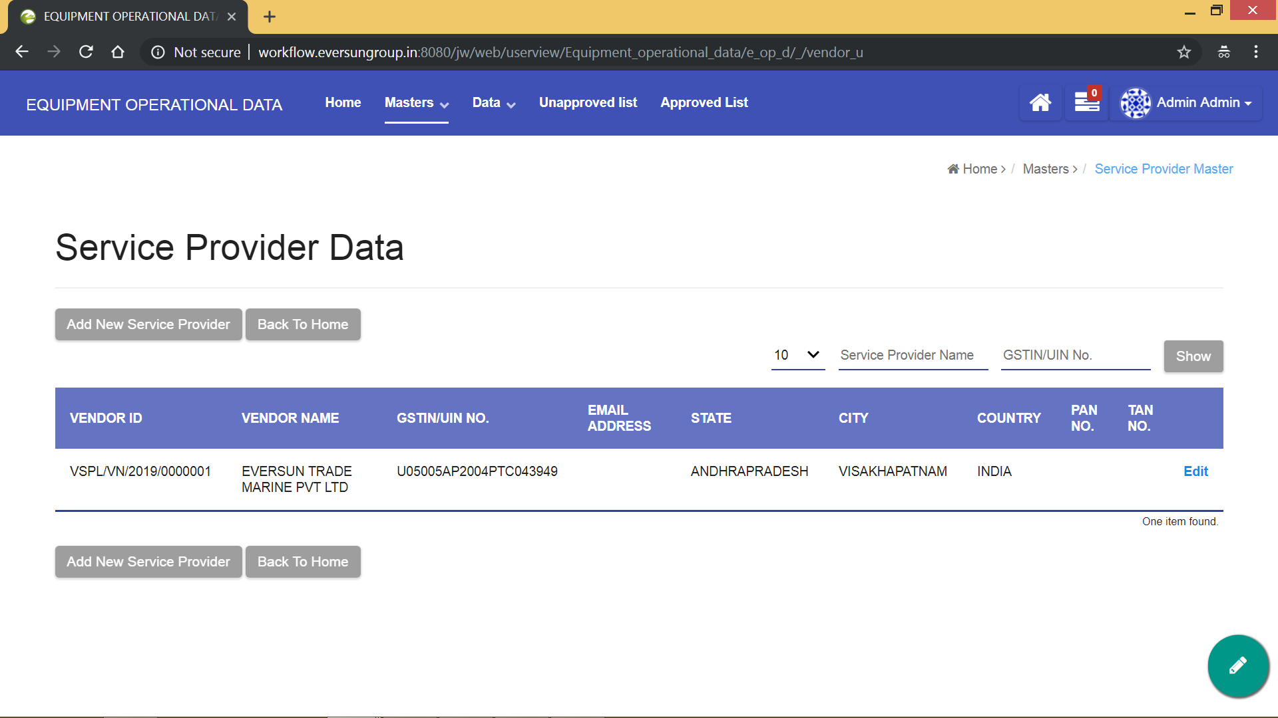

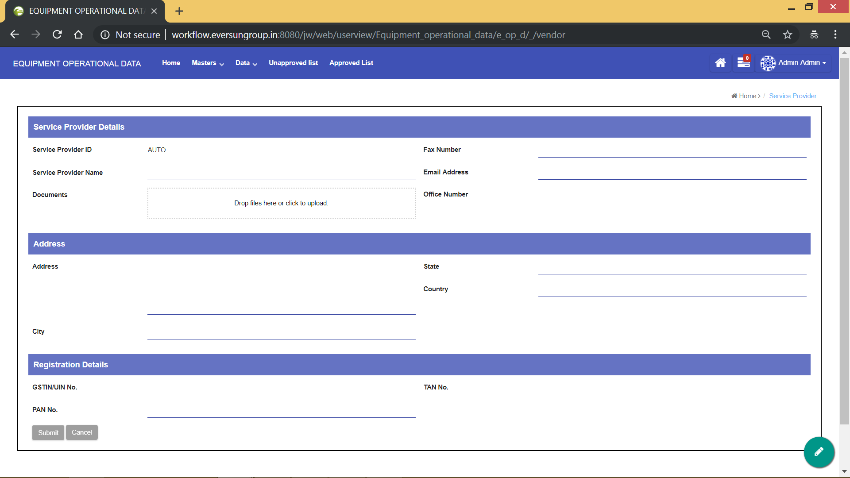

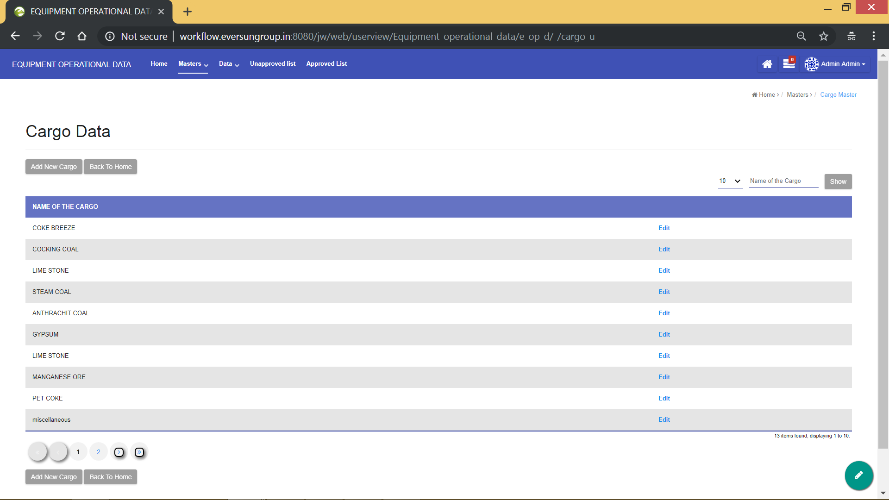

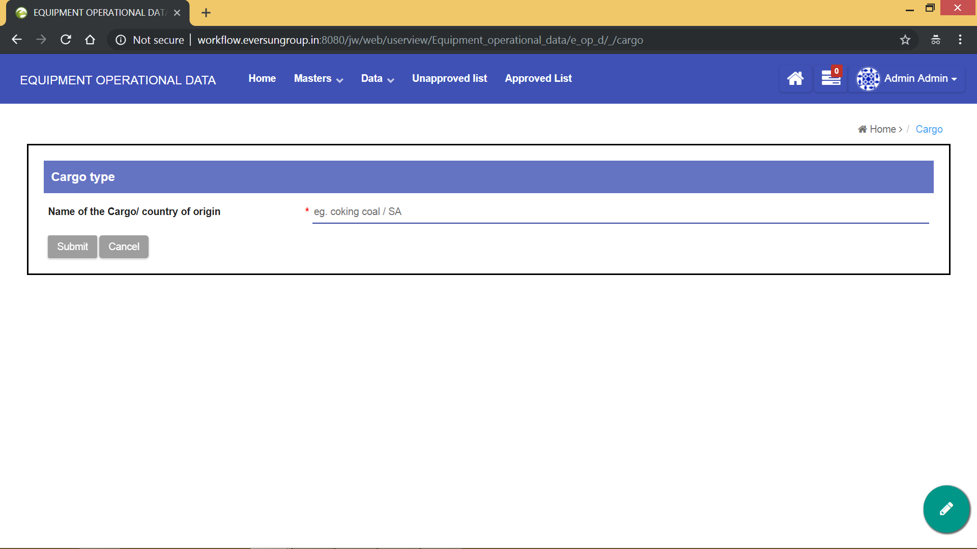

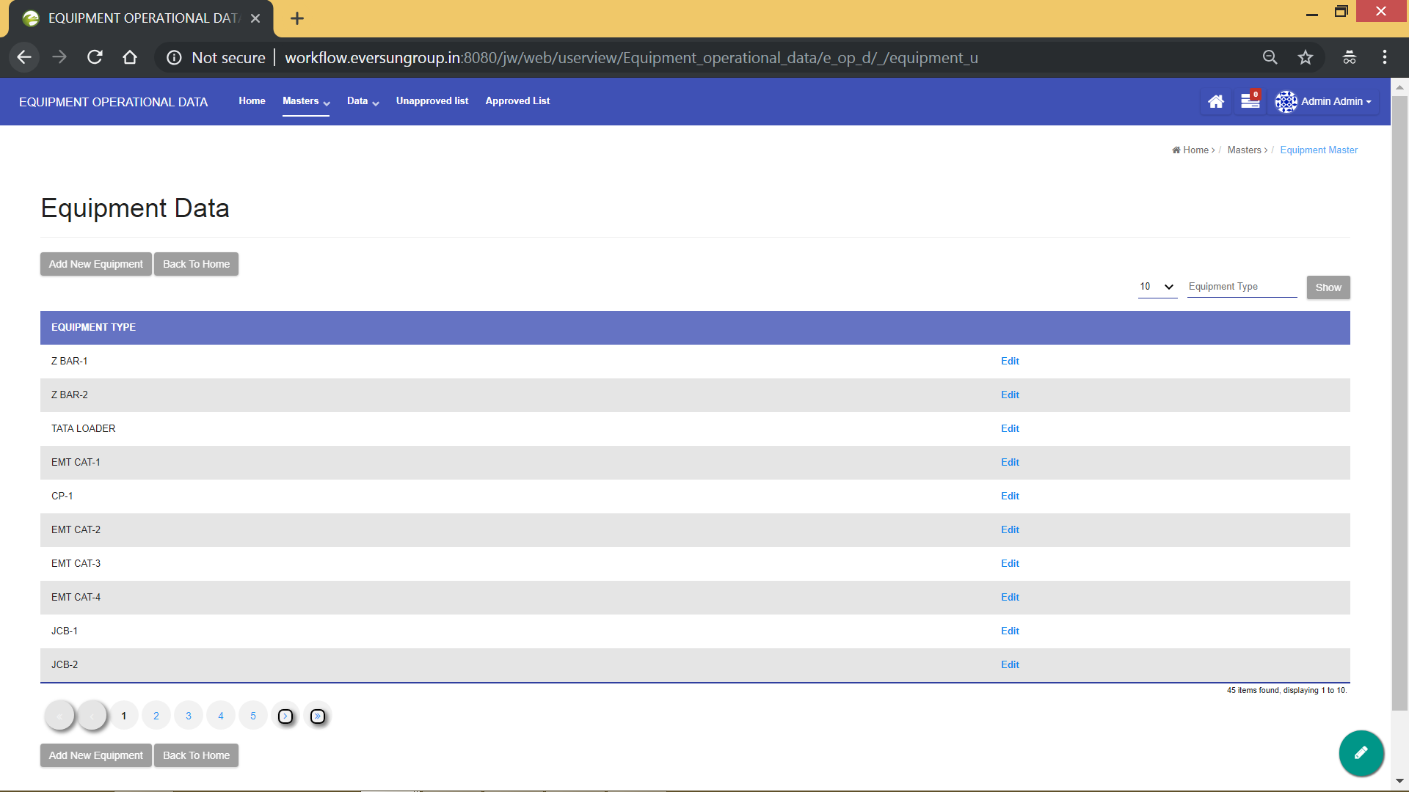

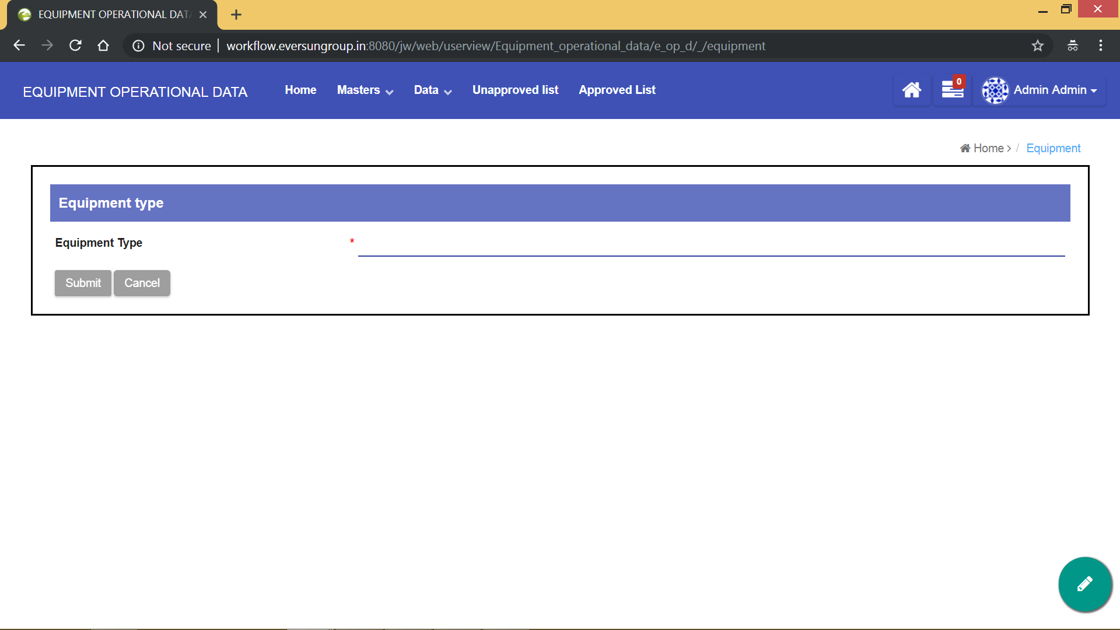

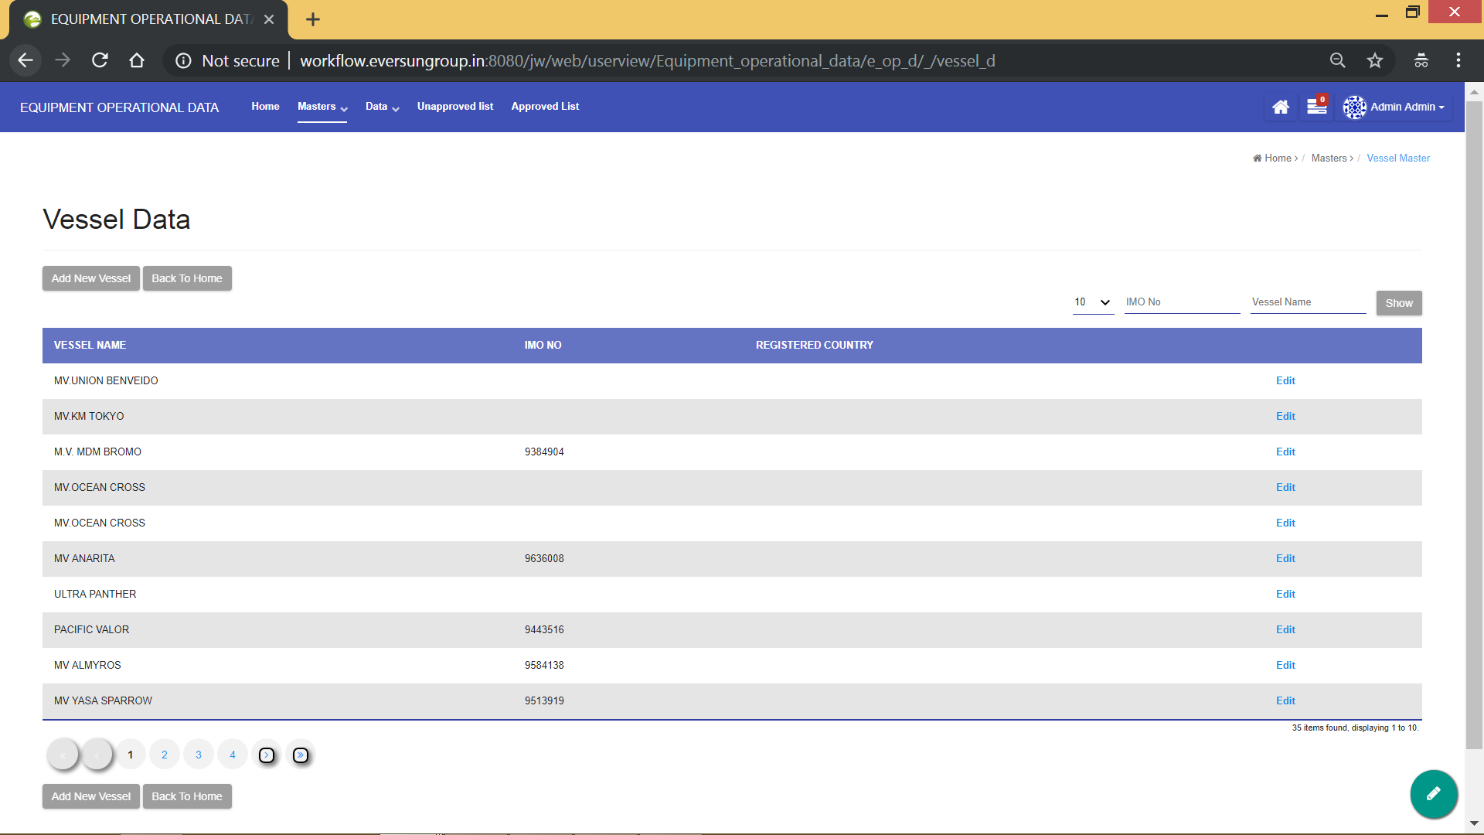

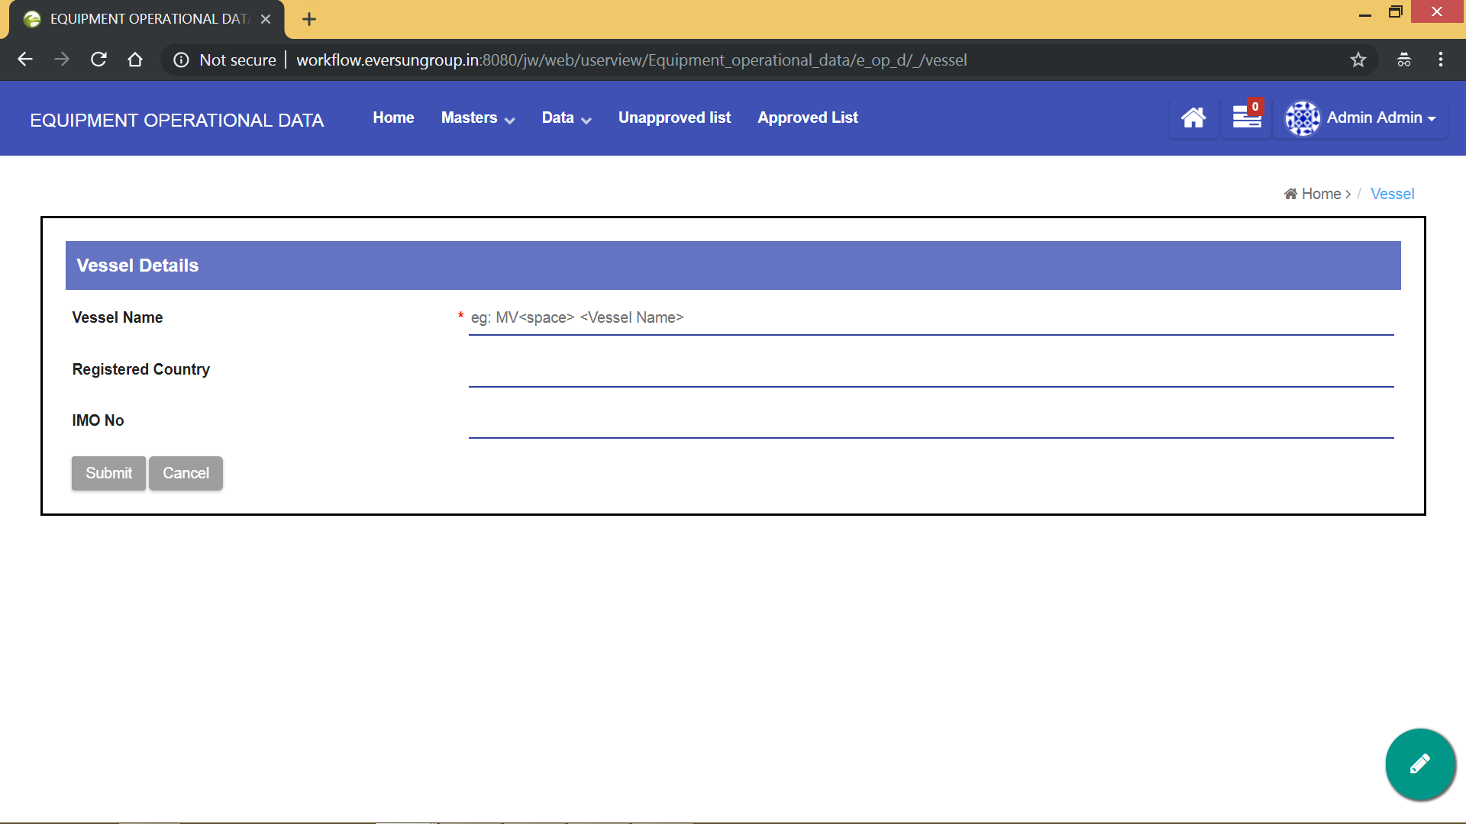

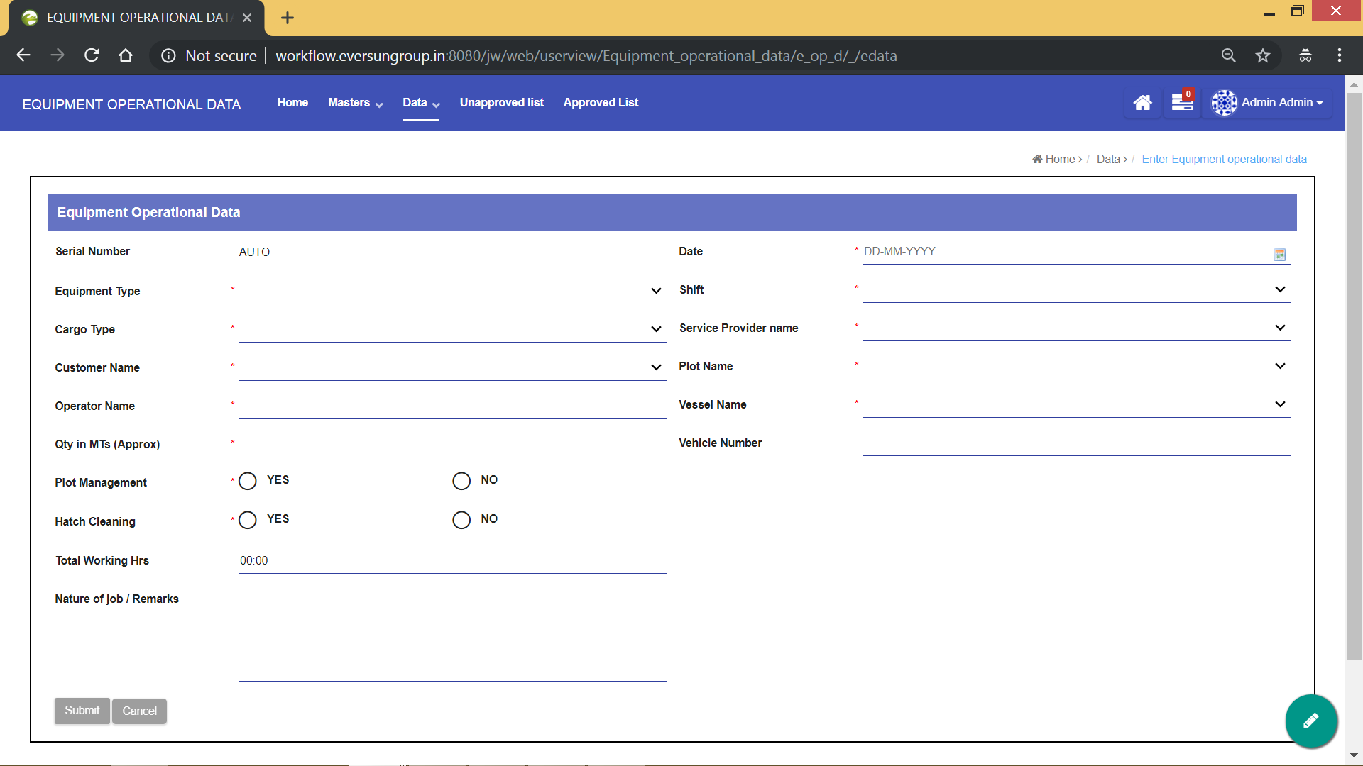

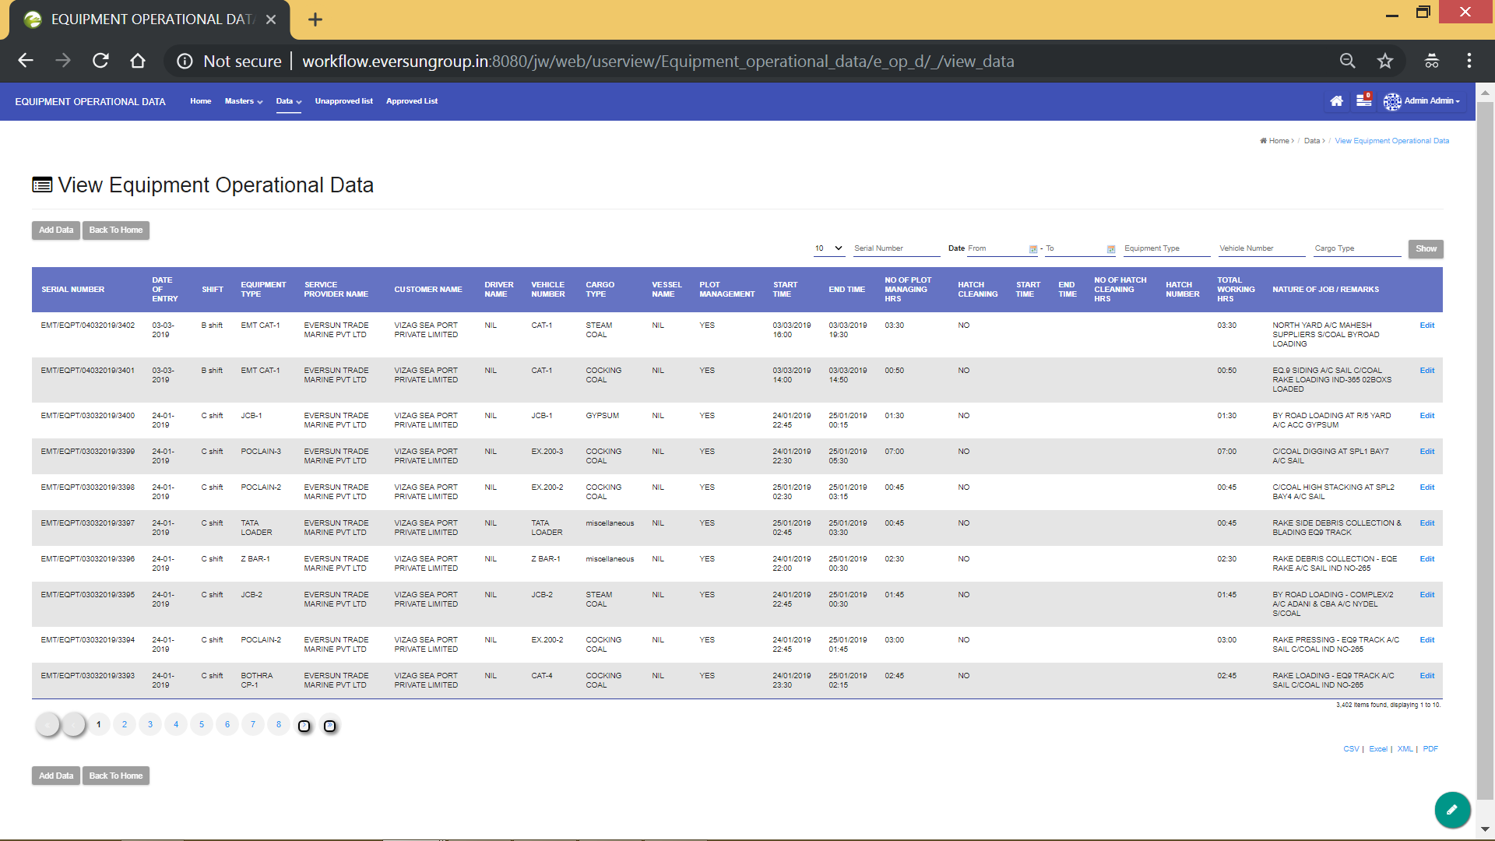

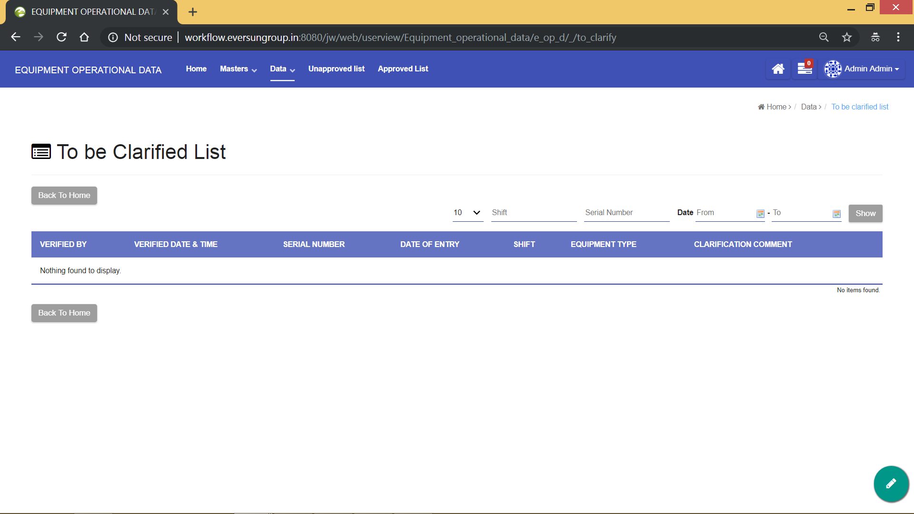

**Shift Incharge View**

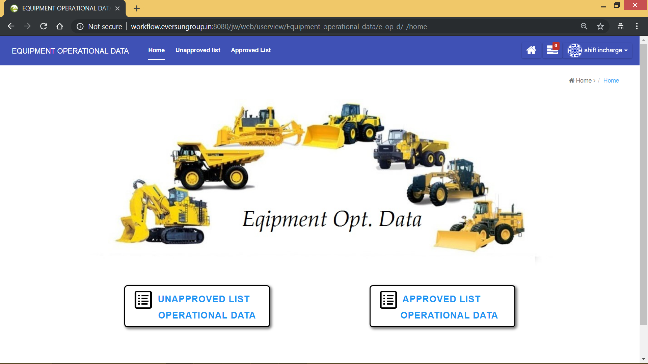

Unlike other users, shift incharge can view only the approved and unapproved list. His task is to approve the data entered by the data entry operator, so he can see only the approved and unapproved lists in his homepage. All the data that is approved goes to the approved list and the data that is yet to be approved stays in unapproved list. Also, there is a provision for the shift incharge to ask for clarification of data.

Data Entry Operator

Data reaches Approved list

Enters or changes data

If shift incharge requires clarification

On shift incharge Approval

Data reaches unapproved list

Data can be filtered and downloaded in required format

**Process**

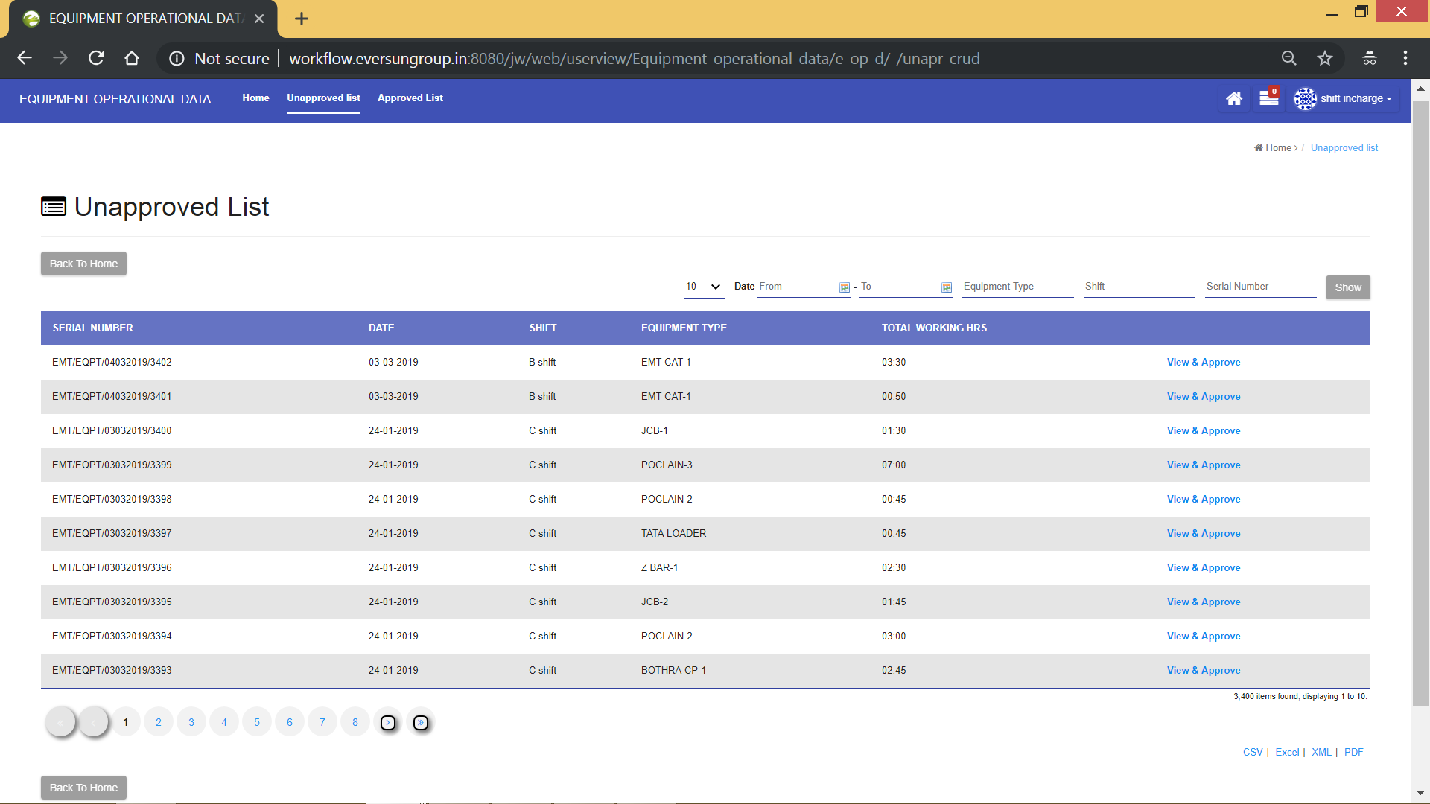

Click on **“View & Approve”** button in the unapproved list to set the status of the entry. The status of the document can either be **“Approved”** or **“Clarification Required”** as shown in below screenshot

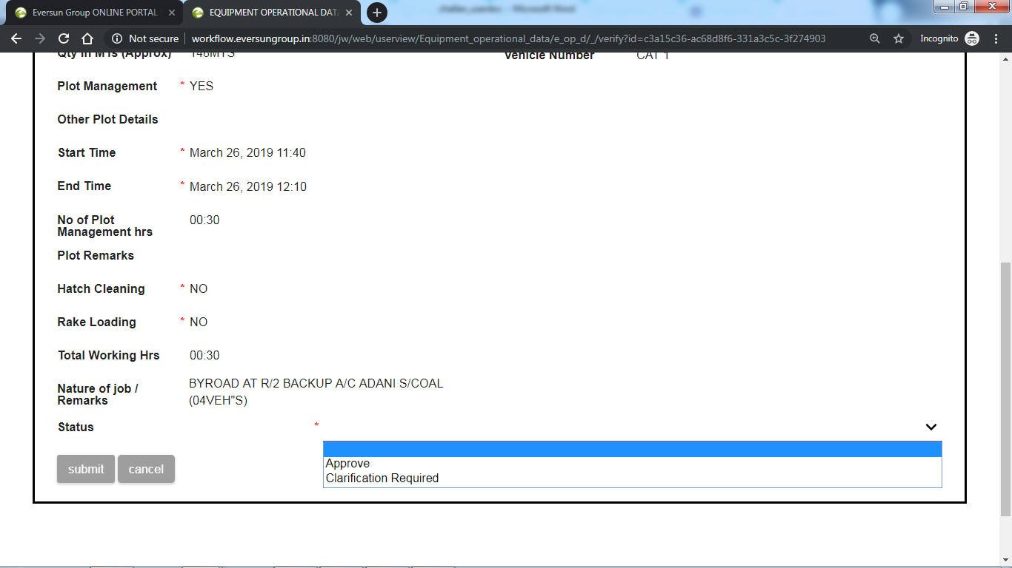

**Status : Approve**

Once the data is verified, then it can be approved by setting status to approve and then submit it. The data once approved is removed from the **“unapproved list”** and is sent **“approved list”.**

**Status: Clarification Required**

If there are any errors in the data, then it can be clarified by setting status to **“Clarification Required”,** comment the reason for clarification and then submit it. This data is sent to “data entry operator” for it to be clarified. After it is clarified, it is again sent back to unapproved list.

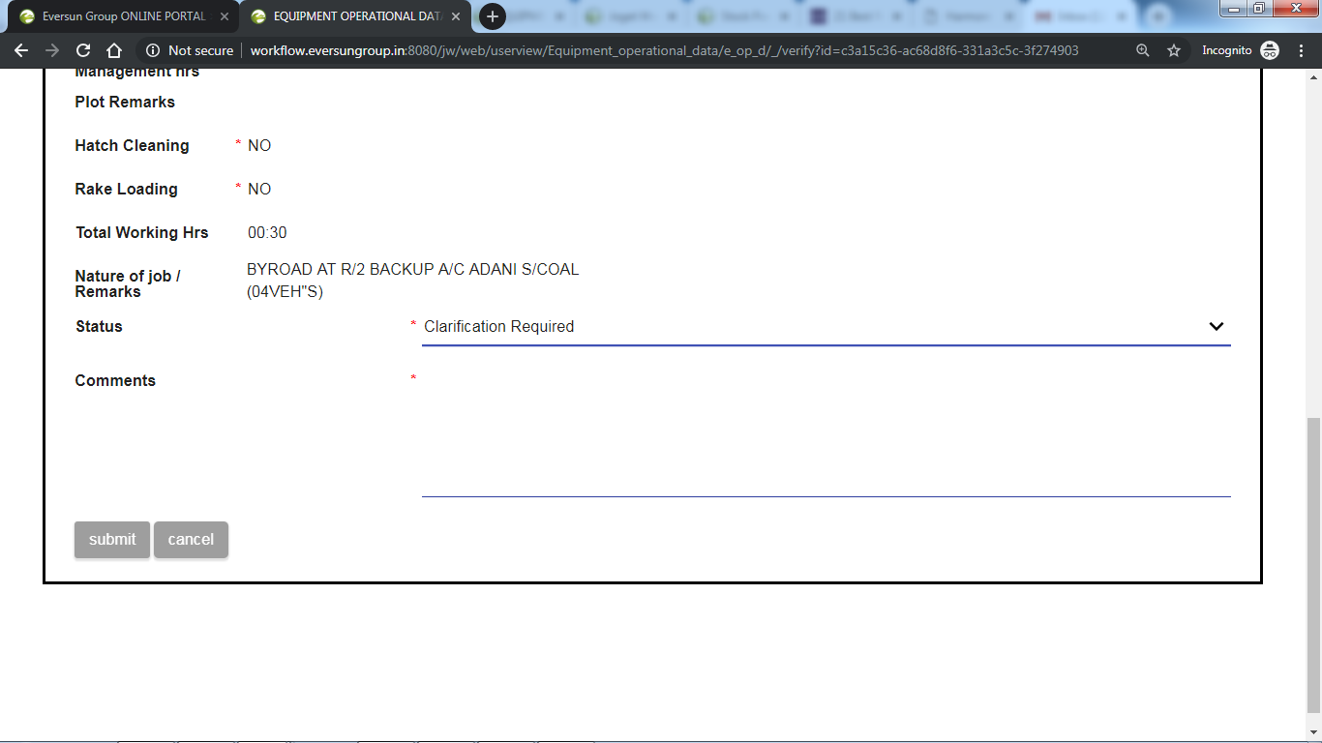

The approved list looks as follows

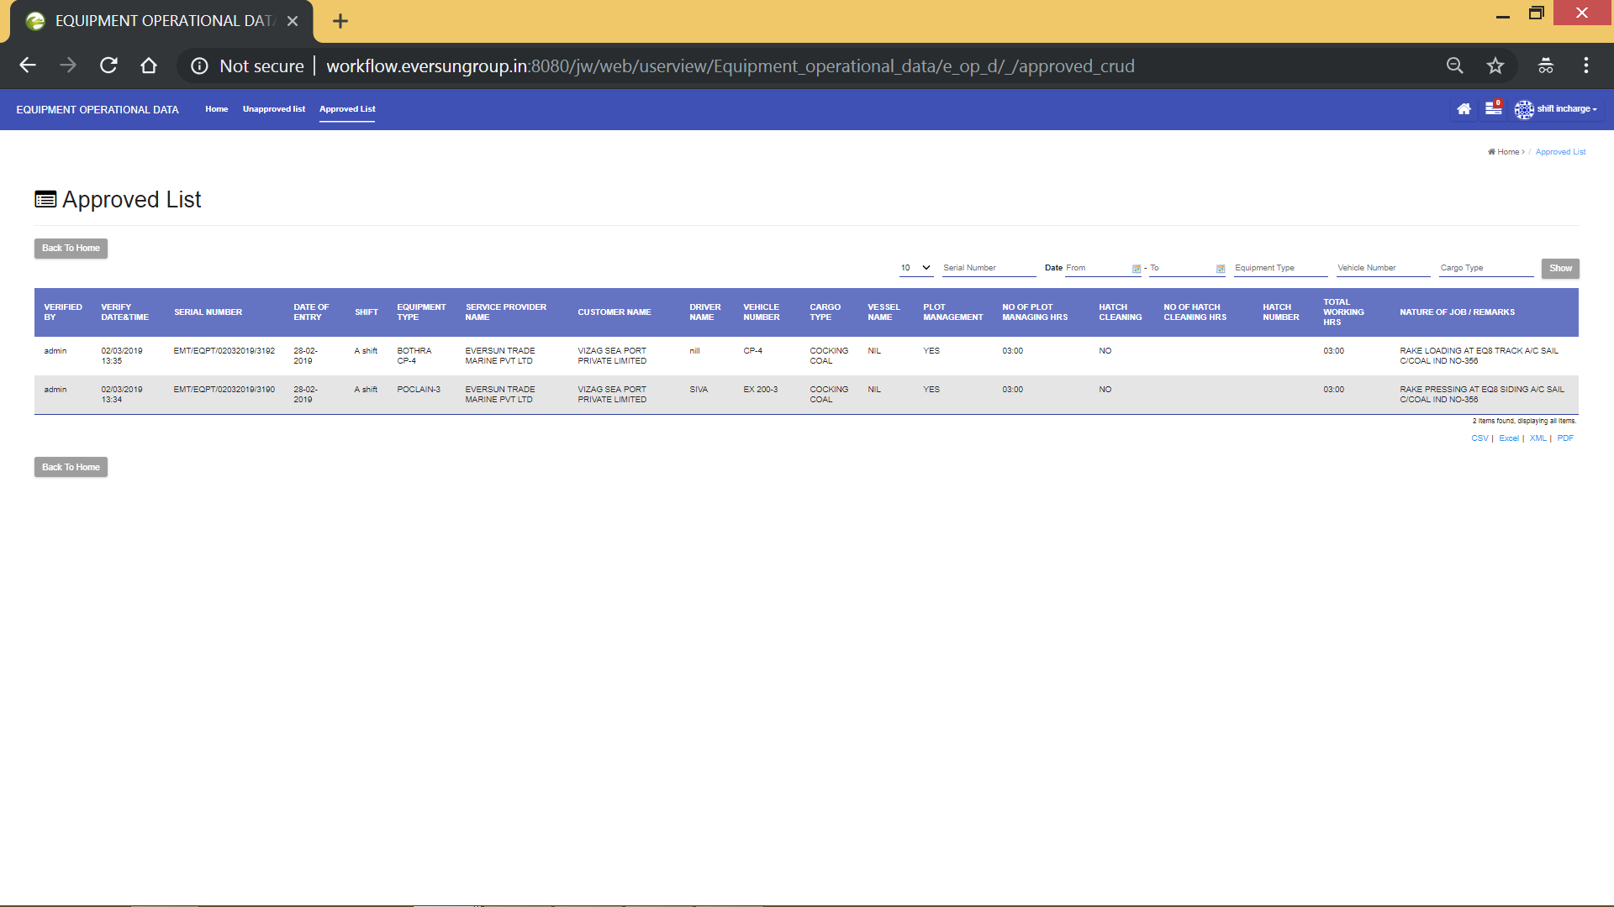The approved data can be downloaded in the required format by clicking on respective format as shown above.

**Data Entry User View**

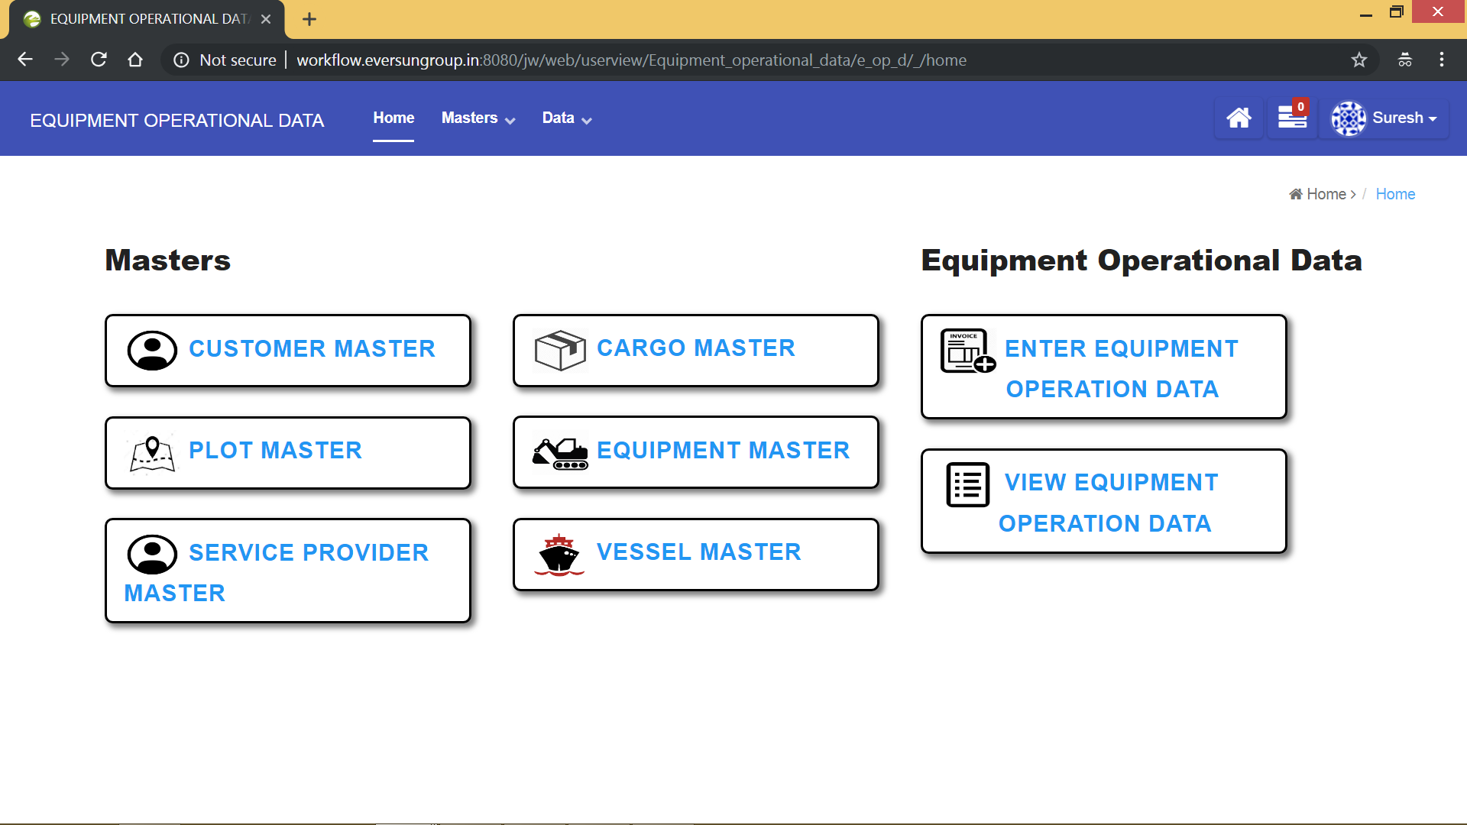

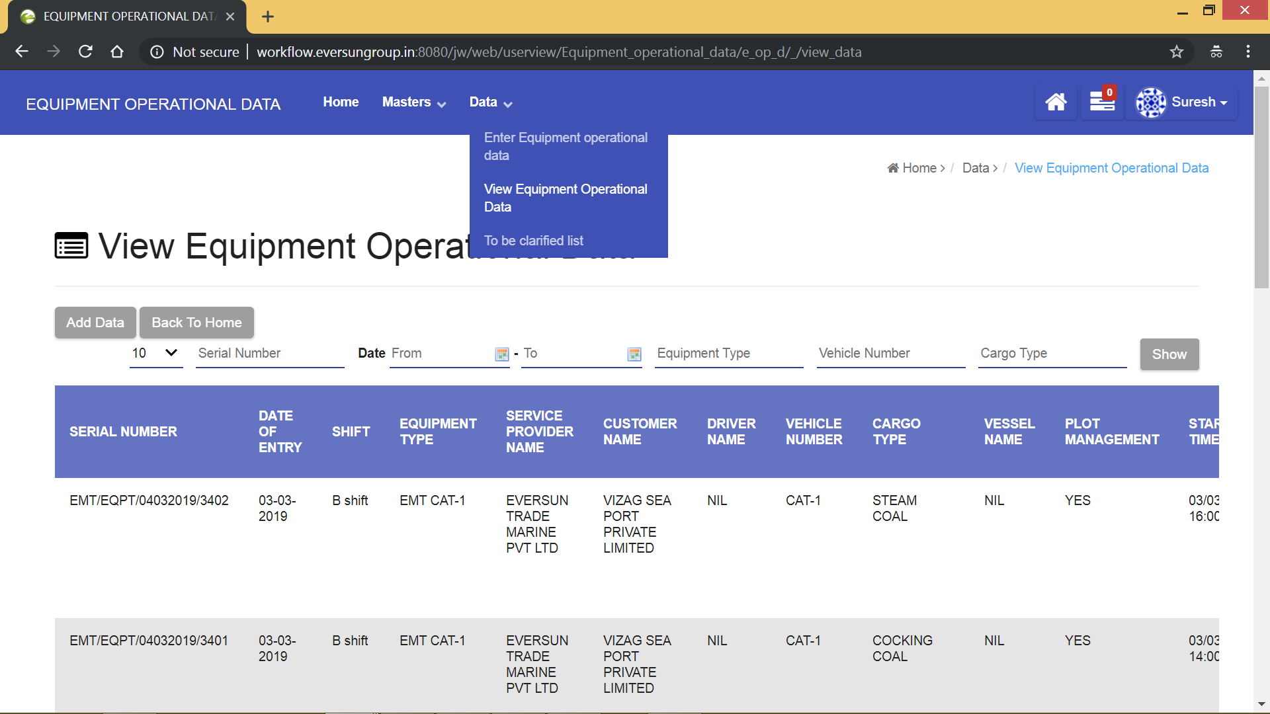

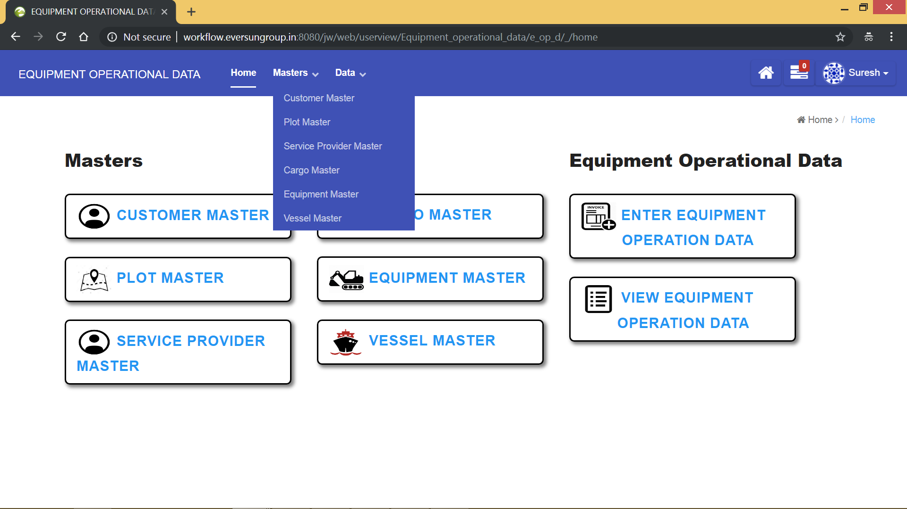

**Workflow**

Concerned officials can filter and download the approved data into EXCEL sheet

Shift Incharge approves the entered data

Data Entry Operator enters the data